TiMotion Sit-Stand Electric Desk
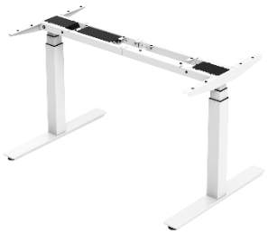  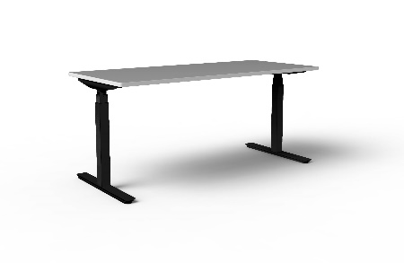  An ergonomic, height adjustable sit-stand electric desk with minimal assembly.  Capabilities  - Variable desktop sizes available (see options)  - Desktop thickness = 25mm  - Frame width range = 1050-1850mm  - Frame height range = 620-1275mm  - Height adjustment speed = 40mm/sec  - Noise level = 39dB  - Standby power = <0.1W  - 100kg maximum weight load  - Minor assembly required | A versatile and ergonomic electric desk offering flexible height adjustment, easy to assemble with the partially pre-assembled frame (assembly time takes less than 6 minutes).  The TiMotion Sit-Stand Electric Desk Frame and Desktop is the ideal solution for creating an ergonomic sit-stand working environment. Features a high-class digital control box with memory buttons, USB charger, and a built-in anti-collision sensor.  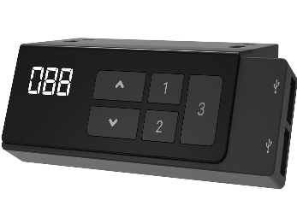  Features  - Dual motor  - Electric height adjustability  - Three step actuators  - Low standby power and low noise level  - Lockable height adjustment  - Steel construction provides high strength and stability  - Pre-assembled frame kit  - Upper and lower height limit settings  - Lock/unlock height adjustment  - Built in anti-collision sensor control box (t-touch)  - USB x 2 charger in control box  - Memory settings  Options  - Black or white desk frame colour.  - Variable sizes of white desktops available:  - 1200 mm x 700 mm  - 1500 mm x 750 mm  - 1500 mm x 850 mm  - 2100 mm x 800 mm  - Extended warranty options.

